- Make sure the Only Jenkins internal database user can login.
Set security realm back to Jenkins’ own user database
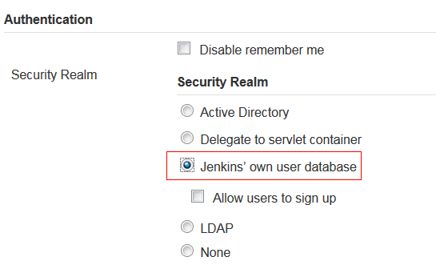
Verify the user’s password.
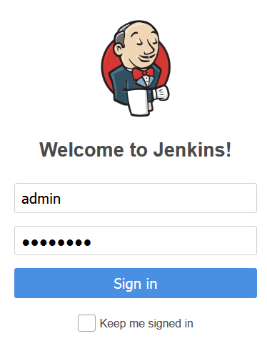
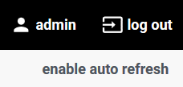
- Set security realm to Active Directory
Setting all the Configuration.
Correct setting as below capture. Using below configuration, domain ID can normally login to jenkins.
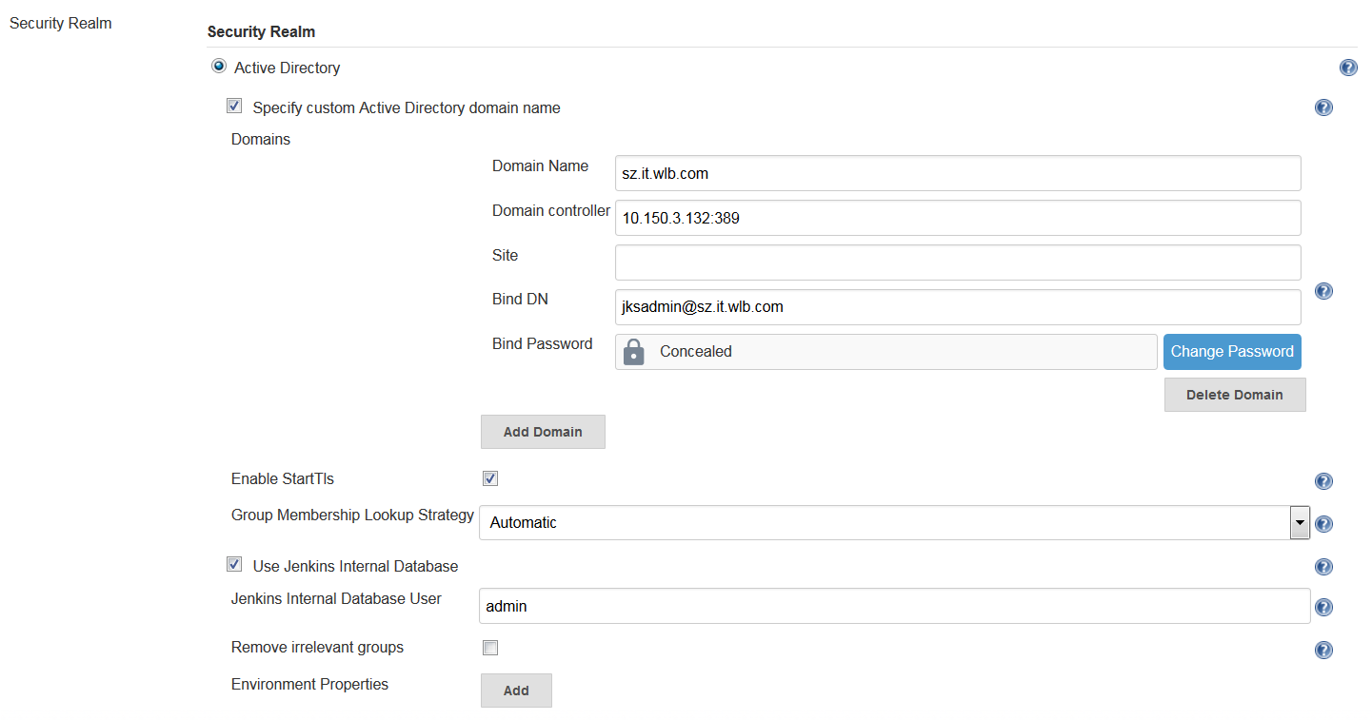
- To test the internal jenkins user admin. I changed the Domain controller’s port to 123 to let jenkins server can’t reached the domain server.
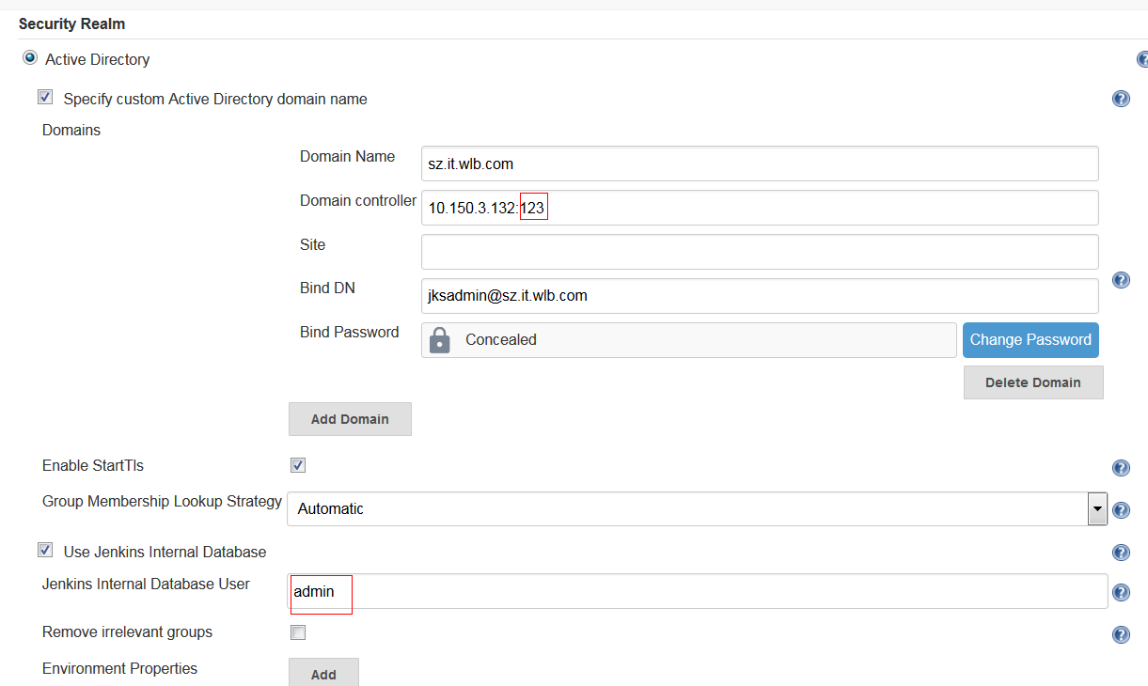
- Logout with admin
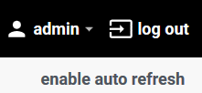
- Login with Domain ID not OK.
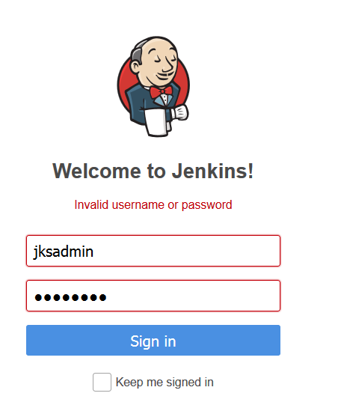
- Login with admin
still not OK.
